SWYNEX TECHNOLOGIES | DATA ANALYTICS INTERNSHIP
Exploratory Data Analysis
YouTube Trending Videos (US): trends, patterns and anomalies
Task 2: Exploratory Data Analysis
Dataset: Cleaned YouTube Trending Videos (US) from Task 1: 40,899 rows, 6,351 videos
Period covered: 14 November 2017 to 14 June 2018
Tools: Python (pandas, NumPy, matplotlib, seaborn)
Prepared by: Gautam Kurpatwar
Date: October 2026

GitHub repository: SWYNEX-Exploratory-Data-Analysis

1. Executive Summary
This report explores the cleaned YouTube Trending Videos (US) dataset from Task 1. It calculates descriptive statistics and identifies trends, patterns and anomalies, supported by 11 charts. The seven main insights are:
- Views are extremely skewed. The mean (2.36 million) is 3.5 times the median (681 thousand), and 11% of rows are statistical outliers. Medians describe a typical trending video better than averages.
- Entertainment has the most volume (24.3%), but Music, Gaming and Film & Animation earn the most views. Their median views are about double those of Entertainment.
- News & Politics and Sports get the lowest like ratios (0.85% and 1.1%) and stay on the trending list for the shortest time (about 4.9 days against 8.1 for Music).
- Timing matters. 32.7% of trending videos were published between 14:00 and 17:00 UTC. Weekend uploads are only 17.7% of rows but have higher median views (752K vs 662K).
- The trending list changed around March 2018. Median days from upload to trending rose from 3.3 to 10.9, median views rose from about 320K to 2.0M, and new videos entering the list fell from about 44 to 12 per day.
- Engagement metrics rise together (views and likes: 0.87), while tags and title length show almost no relationship with views. Shorter titles have a higher like ratio.
- Views roughly double while a video stays on the list (median growth 2.0x for videos with five or more trending days).
Anomalies include 237 old videos revived after more than a year (one after about 11.5 years) and 67 controversial videos with more dislikes than likes.

2. Objective and Scope
The task instructions were to use the cleaned dataset from Task 1, perform exploratory analysis, calculate important statistics, identify trends, patterns and anomalies, and include charts that explain at least five useful insights. This report answers four questions:
- What does a typical trending video look like, and how variable is it?
- Which categories, channels and publishing times are associated with more reach and engagement?
- How has the trending list changed over time?
- Which records are unusual, and why?

3. Dataset and Method

3.1 Dataset
The data is the US file of the Kaggle dataset "Trending YouTube Video Statistics", cleaned in Task 1 (duplicates removed, data types fixed, text standardised, and hidden missing values made explicit). Each row is one video on one trending day, so a video appears once for every day it stayed on the list.
Item | Value
Rows (video-days) | 40,899
Unique videos | 6,351
Unique channels | 2,203
Categories | 16
Period | 14 Nov 2017 to 14 Jun 2018 (205 trending days)
Rows per trending day | about 200 (fixed list size)
Columns | 25 (23 original + 2 flag columns from Task 1)
Missing values | Likes and dislikes: 169 rows (ratings disabled). Comments: 632 rows (comments disabled)

3.2 Method
- Reviewed the cleaned dataset and confirmed there were no duplicate rows or impossible values.
- Calculated descriptive statistics (mean, median, quartiles, maximum, skewness) for views, likes, dislikes, comments, days to trend, tags and title length.
- Compared groups (category, publish day and hour, month) using medians, because the data is highly skewed.
- Measured relationships with Spearman rank correlation, which suits skewed data.
- Detected outliers with the IQR rule and by inspecting extreme values, such as videos that trended after a very long delay or have far more dislikes than likes.
- Visualised results with matplotlib and seaborn. All steps are in src/eda.py and can be re-run.

3.3 Descriptive statistics
Metric | Valid rows | Median | Mean | Maximum | Note
Views | 40,899 | 680,977 | 2,360,649 | 225,211,923 | Skewed
Likes | 40,730 | 18,247 | 74,579 | 5,613,827 | Ratings on
Dislikes | 40,730 | 635 | 3,727 | 1,674,420 | Ratings on
Comments | 40,267 | 1,912 | 8,581 | 1,361,580 | Comments on
Days to trend | 40,899 | 4.8 | 16.2 | 4,214.6 | Outliers
Tags per video | 40,899 | 19 | 19.7 | 69
Title length (characters) | 40,899 | 46 | 48.6 | 100
The mean is far above the median for views, likes, dislikes and comments, which shows a long right tail caused by a small number of viral videos.

4. Findings and Insights
Each chart below is numbered and carries its own note and data source. Figures use medians unless stated.

4.1 Views are heavily right-skewed
The mean views per video-day (2.36 million) is 3.5 times the median (681 thousand). By the IQR rule, 4,498 rows (11.0%) are outliers above 4.19 million views. The most-viewed video, Childish Gambino – This Is America, has 225 million views. Every major category contains extreme outliers (panel b), so medians are used throughout this report.
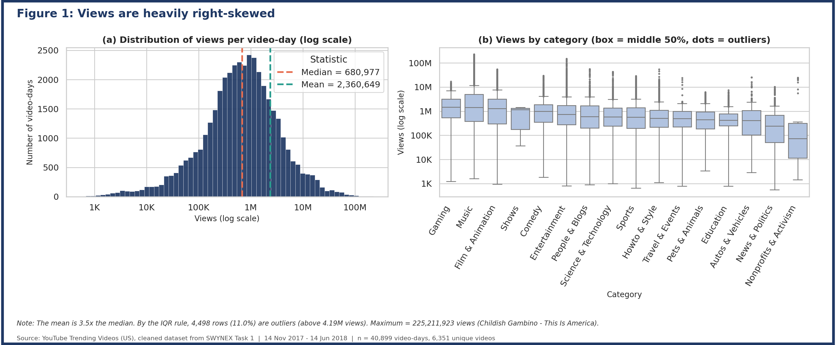

4.2 Entertainment dominates volume; Music, Gaming and Film dominate reach
Entertainment (24.3%) and Music (15.8%) account for 40% of all trending rows. Reach is a different story: the highest median views belong to Gaming (1.49M), Music (1.43M) and Film & Animation (1.27M), about twice Entertainment (734K). News & Politics has the lowest reach of the large categories (244K).
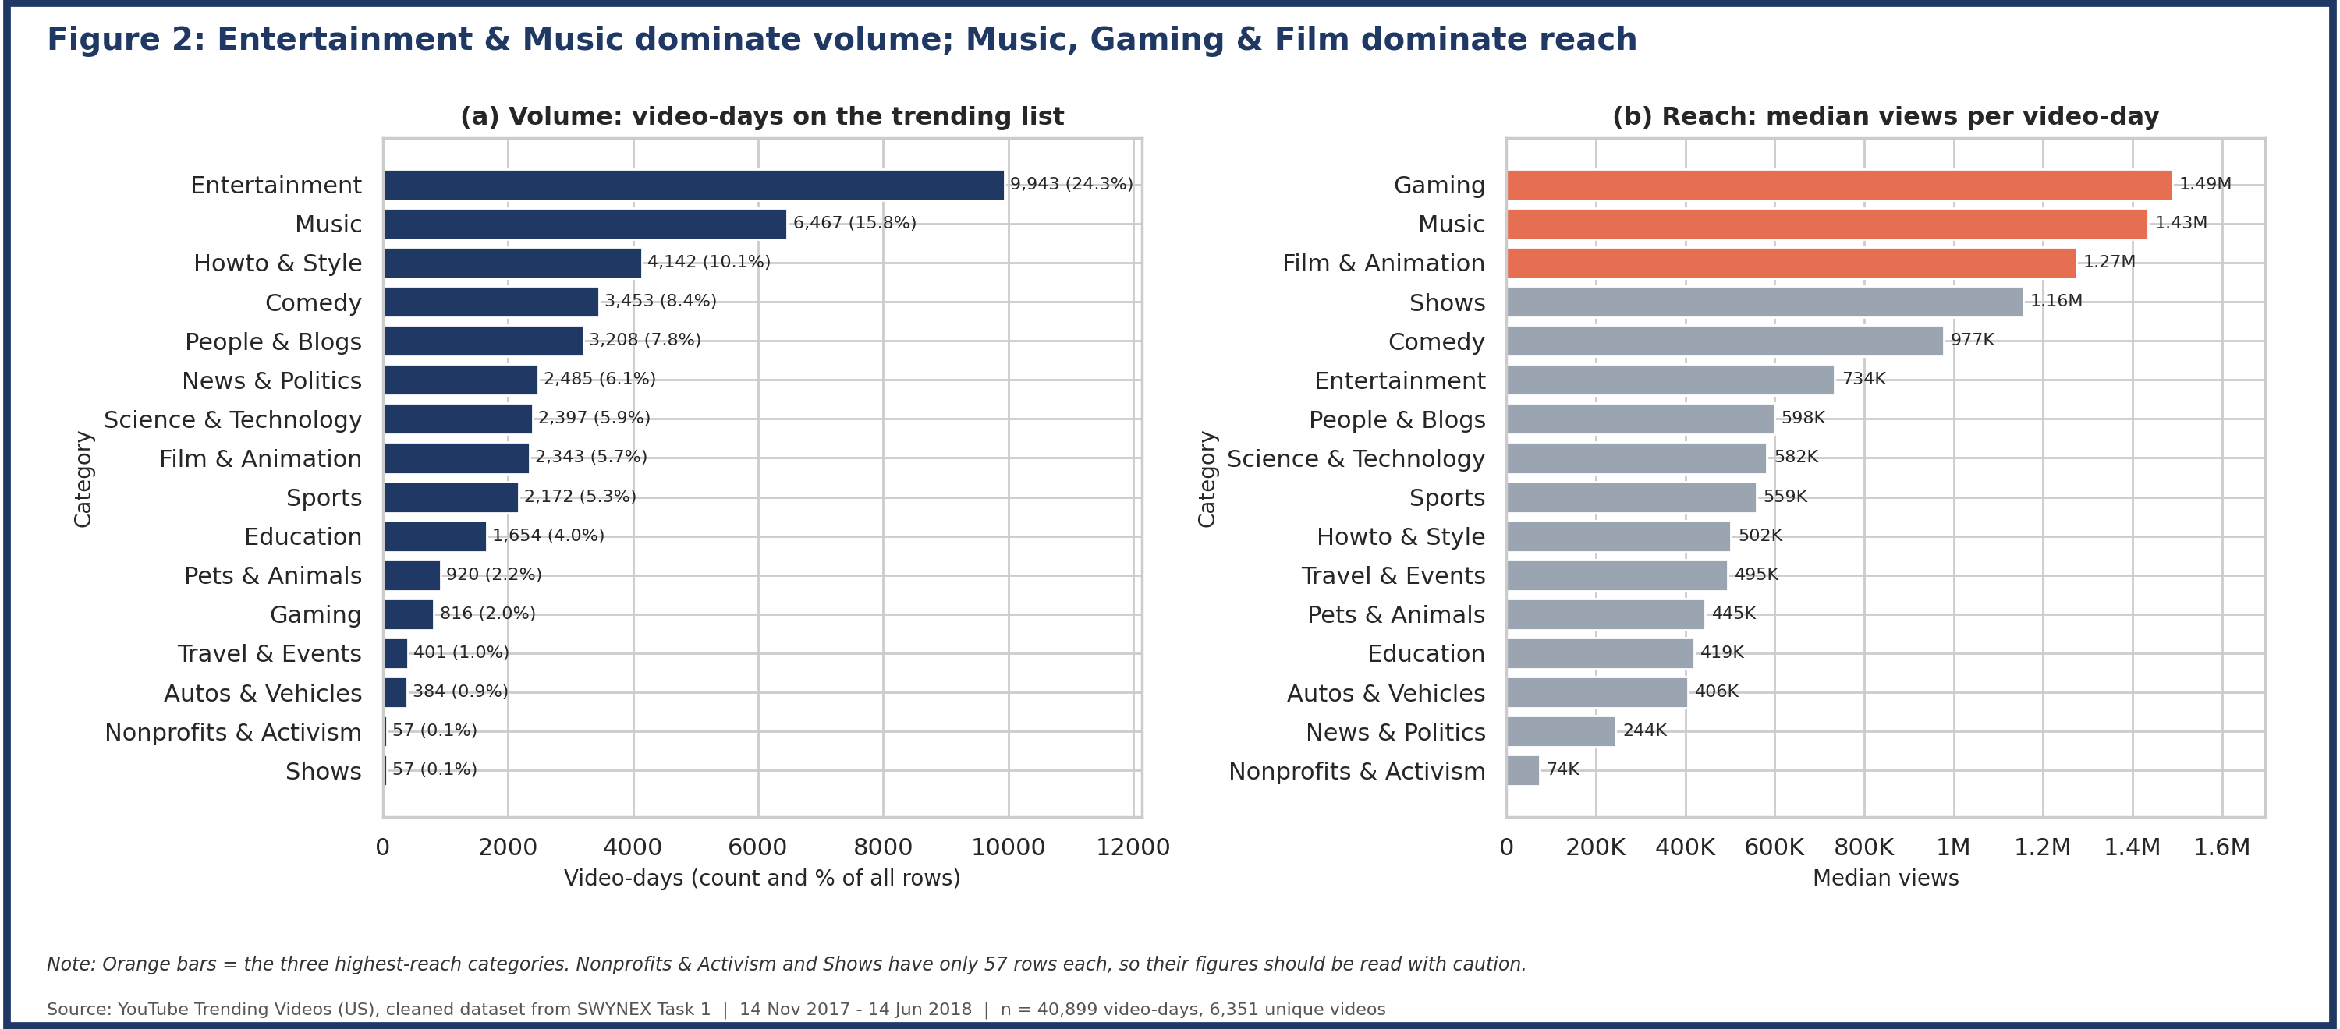

4.3 News and Sports: fewer likes and a shorter time on the list
The median like ratio is 0.85% for News & Politics and 1.08% for Sports, against 4.31% for Howto & Style. News and Sports videos also stay on the trending list for the shortest time (4.9 and 4.8 days on average, versus 8.1 for Music). This suggests quick-turnaround content attracts views but fades fast. "Shows" has the longest stay but is only four videos.
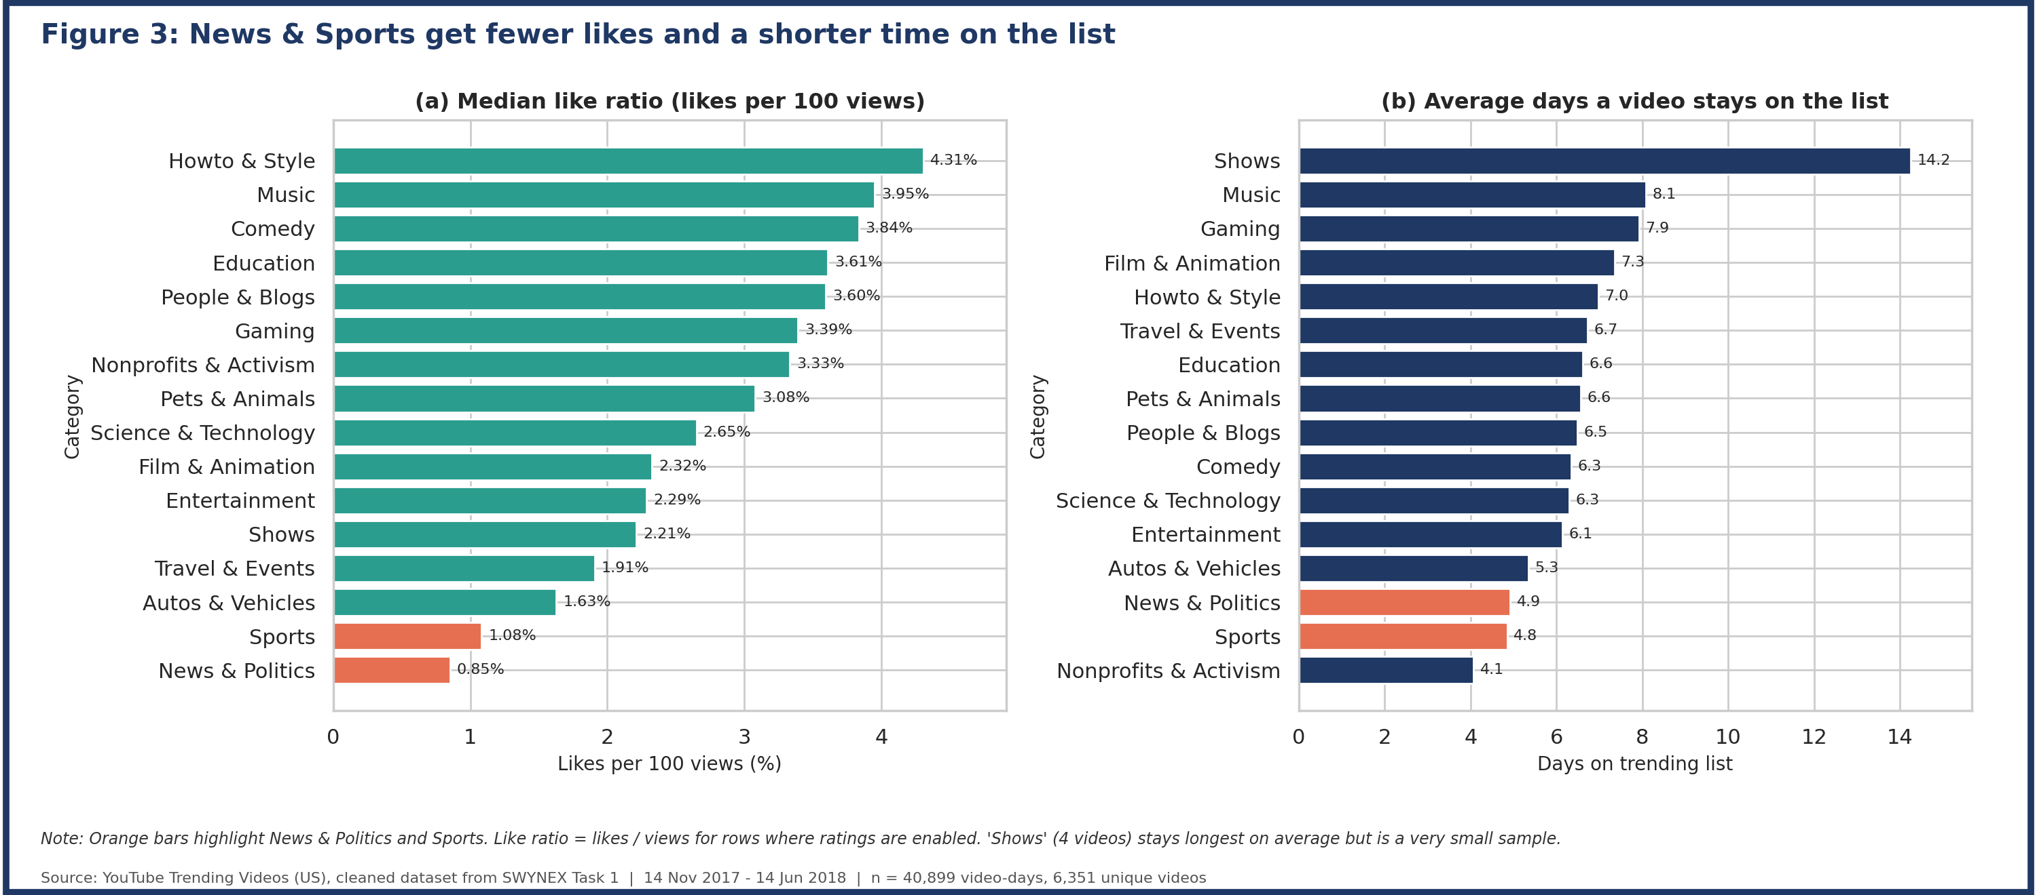

4.4 Publishing time: weekday afternoons (UTC) peak
32.7% of trending rows were published between 14:00 and 17:00 UTC, roughly 9am to 12pm US Eastern. The heatmap shows the busiest cells on Tuesday to Thursday around 15:00 to 17:00 UTC.
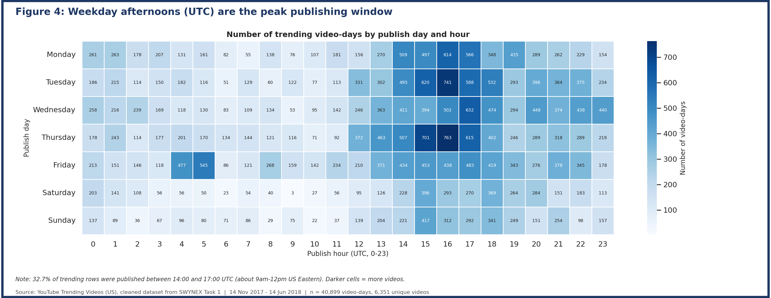

4.4 (continued) Weekend uploads are fewer but earn higher median views
Weekends make up only 17.7% of trending rows (28.6% if uploads were evenly spread), yet weekend-published videos have a higher median view count (752K vs 662K on weekdays). Less competition may help a weekend video stand out; this is an association and not proof of cause.
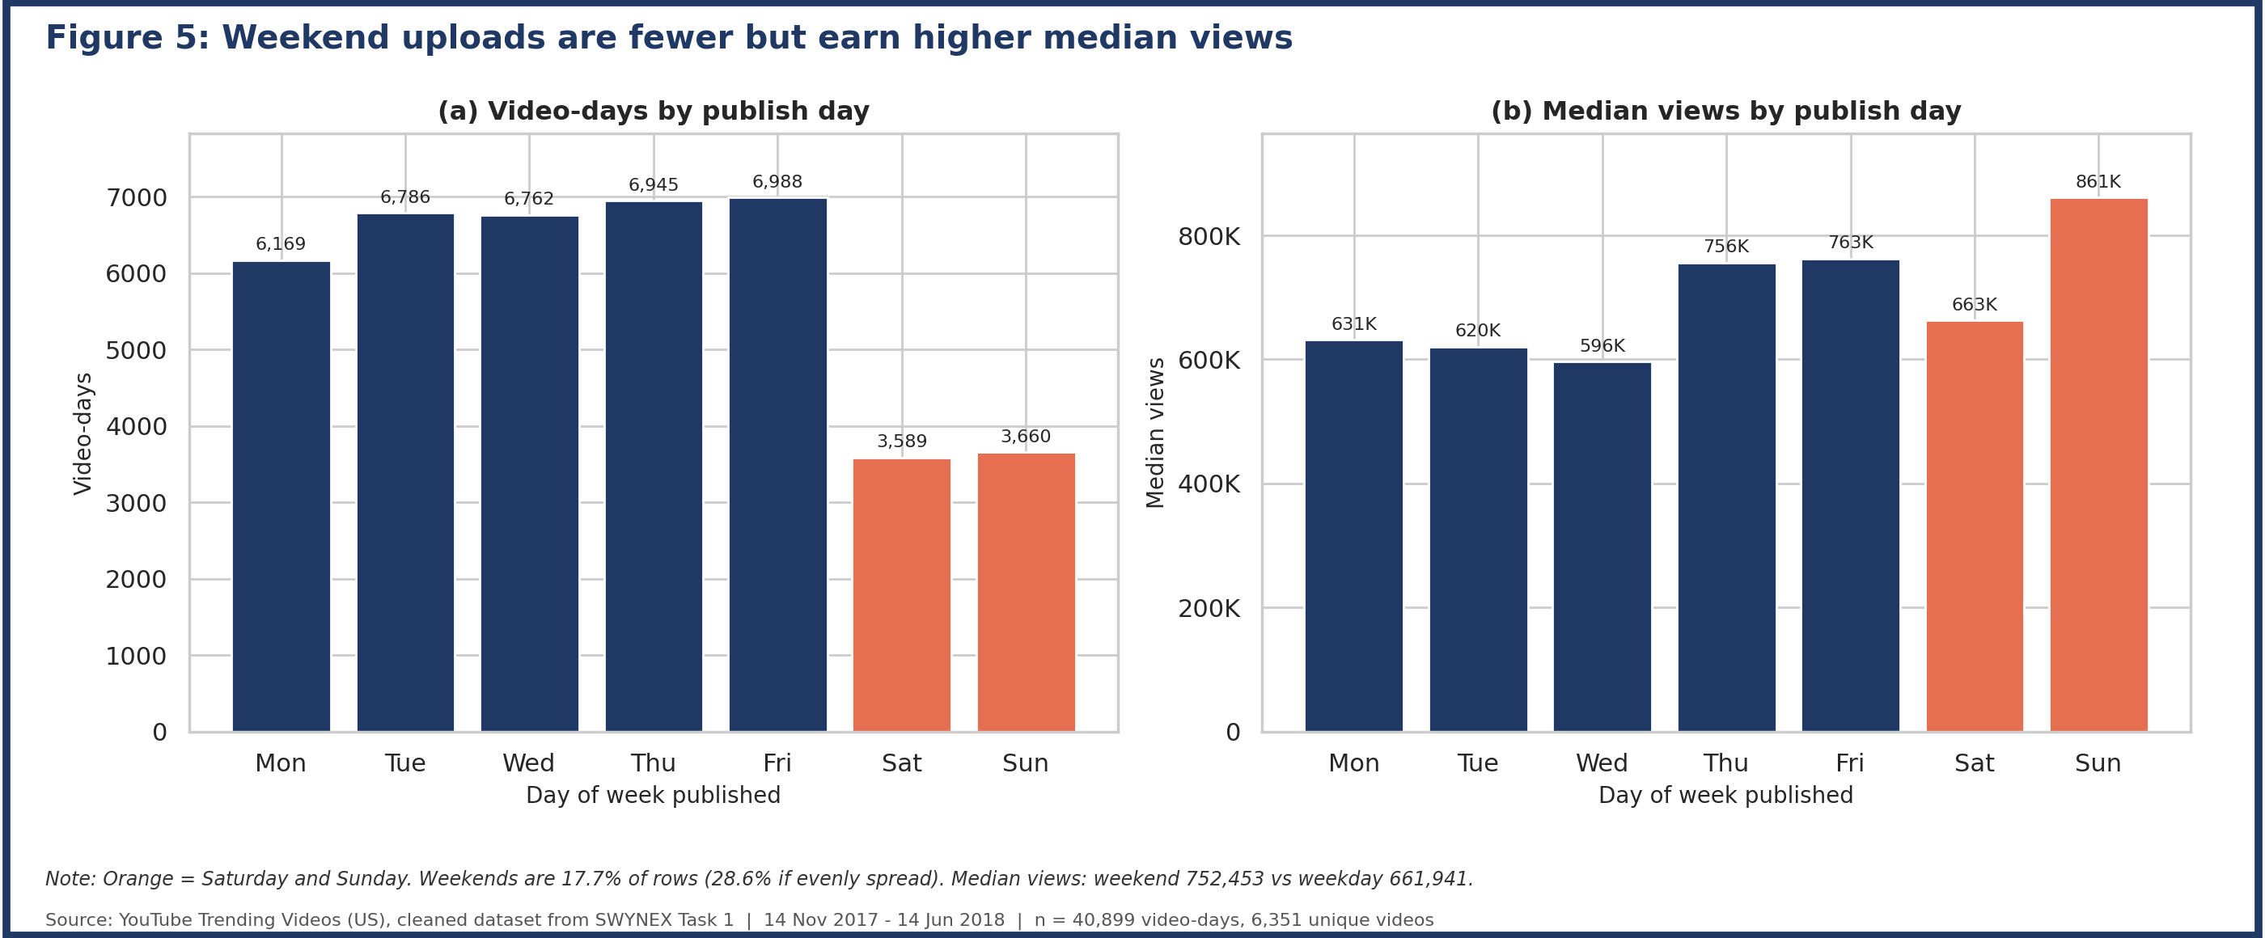

4.5 The trending list changed around March 2018
From March 2018 the list became dominated by bigger, slower-to-trend videos: median views per video-day grew from about 320K (Nov 2017) to 2.0M (Jun 2018), median days from upload to trending rose from 3.3 to 10.9, and new videos entering the list per day fell from about 44 to 12. A change in how YouTube selects trending videos is a plausible explanation, but the data alone cannot prove it. June covers only 14 days.
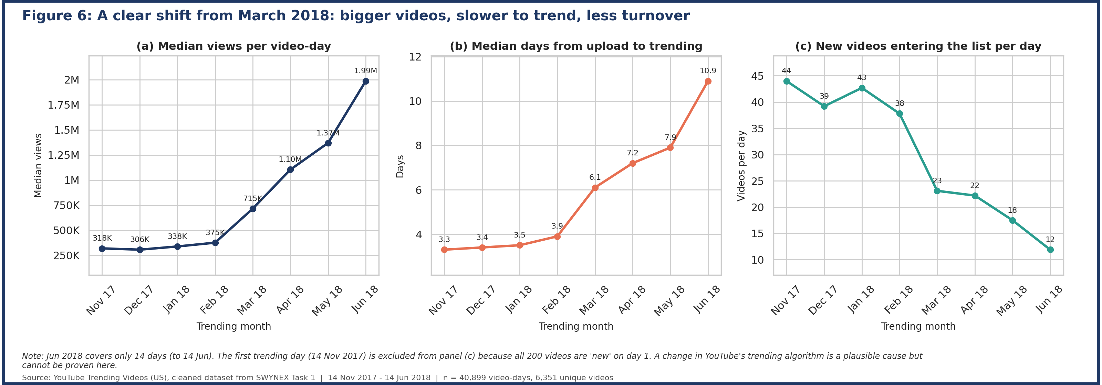

4.6 Engagement metrics move together; tags and title style barely matter
Views, likes, dislikes and comments are strongly correlated (views and likes 0.87, views and comments 0.83). Tag count (0.08) and title length (-0.07) have almost no rank correlation with views.
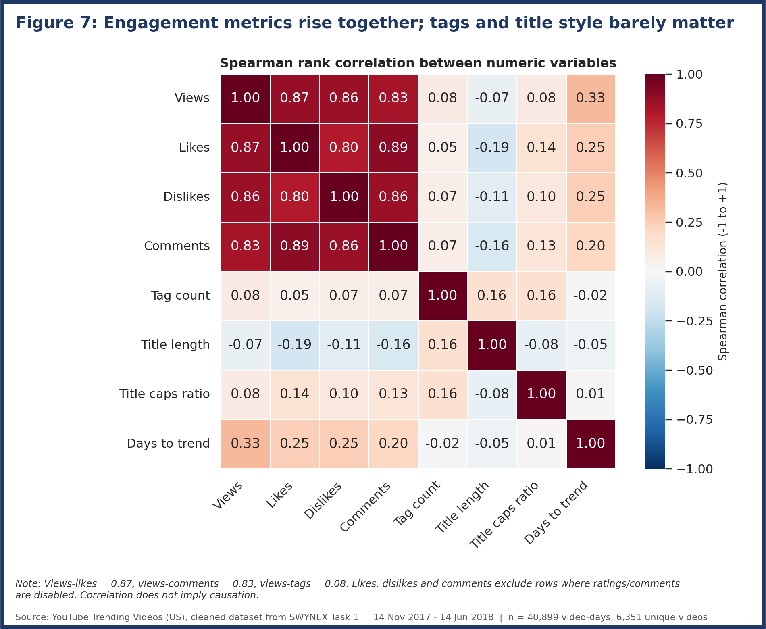

4.6 (continued) Title length and tags
Shorter titles earn a higher like ratio (3.73% for titles up to 30 characters vs 1.80% for 71 to 100 characters). Videos with 21 to 30 tags show a higher median view count (850K) than videos with no tags (494K). These are associations, not proof that changing titles or tags causes the difference.
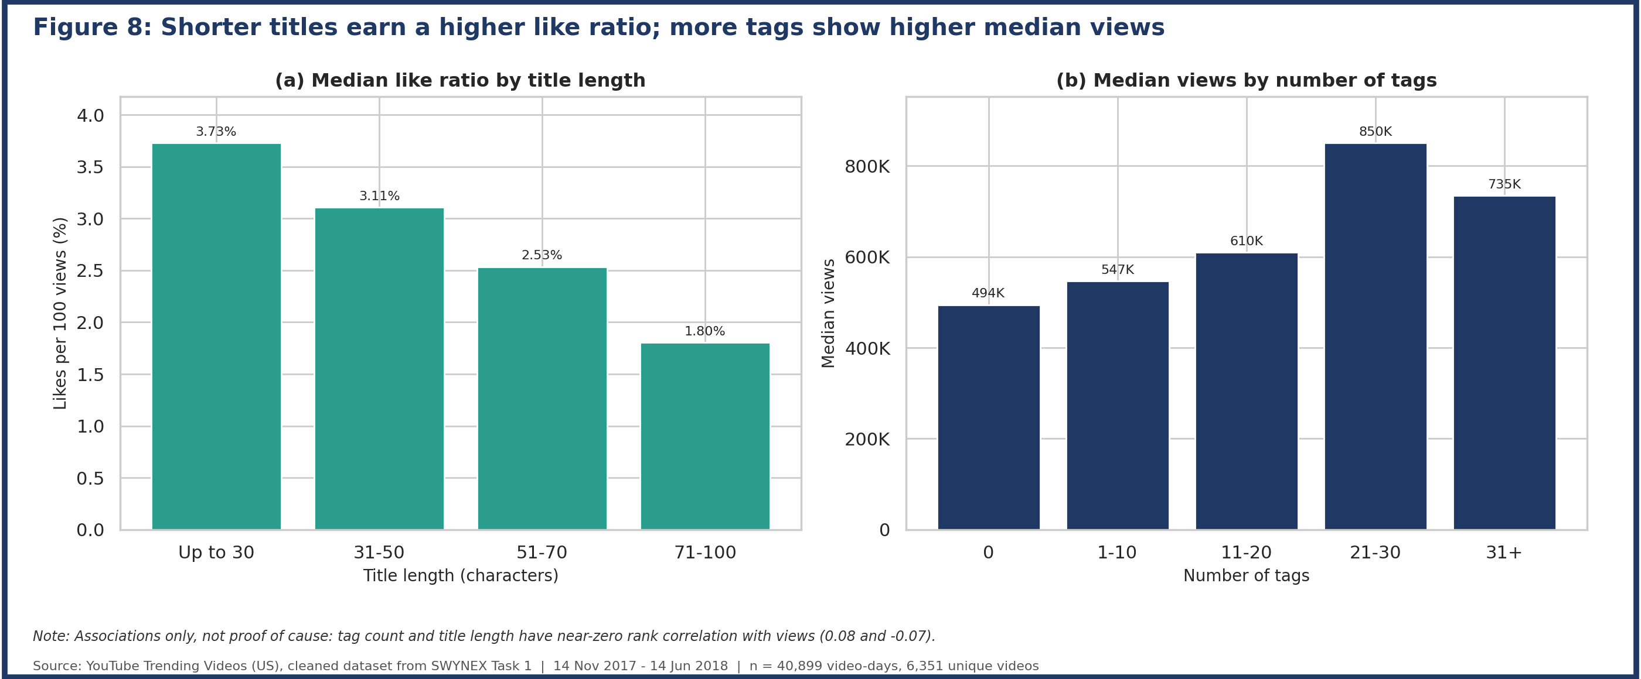

4.7 Channels: a long tail rather than a few dominant creators
The most frequent channels are late-night shows (The Tonight Show, The Ellen Show, Jimmy Kimmel Live, The Late Show), sports (ESPN, NBA) and media brands (Netflix, Vox). Even so, the top 10 channels account for only 4.6% of rows, because 2,203 channels appear in total.
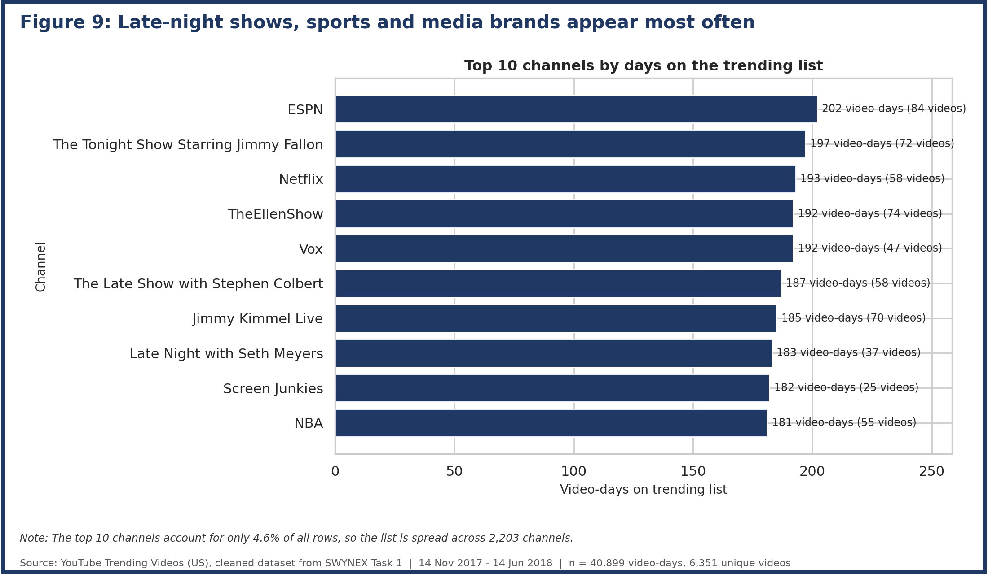

4.8 Anomalies: revived old videos, controversial videos and disabled comments
237 rows trended more than a year after upload, the extreme being a Budweiser ad that trended 4,214 days (about 11.5 years) later. 67 videos with at least 100K views have more dislikes than likes, many political (for example FCC net neutrality videos and Roy Moore statements); YouTube Rewind 2017 reached 1.64 million dislikes. Comments are disabled most often in News & Politics and Nonprofits & Activism (about 7% of video-days).
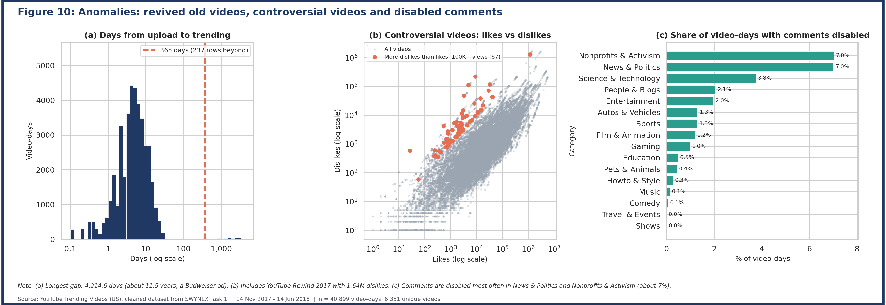

4.9 Views roughly double while a video stays on the list
For the 3,981 videos that stayed on the list five or more days, the median video had 2.0 times the views on its last day as on its first. The median stay for all videos is 6 days, 1,209 videos lasted 10 days or more, and the longest lasted 29 days.
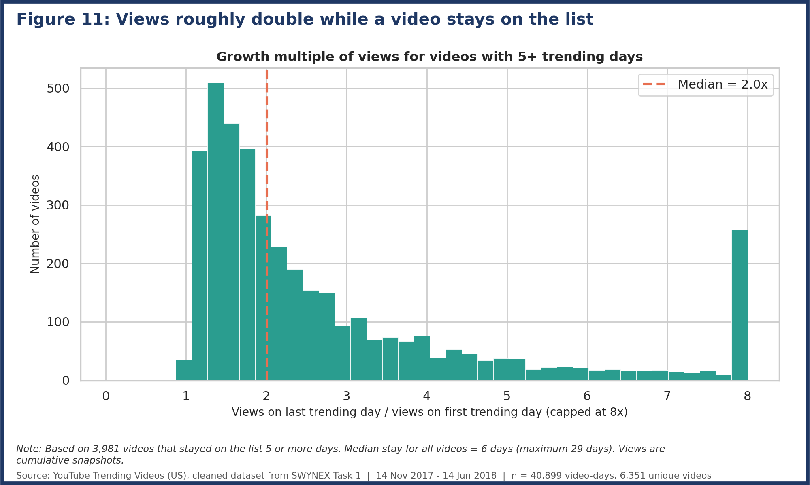

5. Anomalies Summary
Anomaly | Finding | File
Extreme view counts | 4,498 rows above 4.19M views (IQR rule); Music is the largest share (40%) | reports/anomaly_top_view_outliers.csv
Old videos revived | 237 rows trended over 365 days after upload; maximum 4,214.6 days | reports/anomaly_old_videos_revived.csv
Controversial videos | 67 videos (100K+ views) with more dislikes than likes | reports/anomaly_controversial_videos.csv
Disabled comments / ratings | Comments disabled in 632 rows, ratings in 169; handled as missing, not zero | Task 1 cleaning log
Video ID conflicts | 97 rows share a video ID with different channels or upload times; flagged, not removed | Task 1 cleaned data

6. Recommendations
- Report medians and per-category figures, not overall averages, because of the heavy skew.
- Creators targeting the trending list can consider weekend uploads and shorter titles, which are associated with higher median views and like ratios respectively.
- Analyse before and after March 2018 separately, since the behaviour of the list changed.
- Treat News and Sports as short-lived traffic and Music and Gaming as sustained, high-reach content when planning content or campaigns.
- Handle disabled ratings and comments as missing values and not as zero, or averages will be biased downwards.

7. Limitations
- Only videos that reached the trending list are included, so findings do not describe YouTube as a whole.
- Views, likes and comments are cumulative snapshots on each trending day, not daily values.
- The data covers the US only, from November 2017 to June 2018; June is a partial month.
- Associations (correlations and group differences) do not prove cause.
- Small groups such as Shows (4 videos) and Nonprofits & Activism (14 videos) should be interpreted with caution.

8. Conclusion
The trending dataset is dominated by a long tail of moderately popular videos and a small number of viral hits, so typical performance is best described by medians. Reach, engagement and staying power differ clearly by category, and publishing time shows consistent patterns. The most important discovery is the shift in the behaviour of the trending list from March 2018, which anyone using this data for time-based comparisons should account for. The analysis is fully reproducible from the repository.

Appendix A: Repository Contents
Path | Purpose
README.md | Project summary, insights, how to run
src/eda.py | Complete, reproducible analysis script
data/youtube_trending_us_cleaned.csv | Cleaned dataset from Task 1
charts/ (11 PNG files) | Report-ready figures
reports/*.csv, EDA_summary_tables.xlsx | Summary tables behind each chart
reports/EDA_Figures_Report.pdf | All 11 figures in one PDF
docs/data_dictionary.md | Description of all 25 columns
docs/SWYNEX_EDA_Report (.docx, .pdf) | This report
requirements.txt | Python packages needed

